# SDSS GALAXY CLASSIFICATION USING MACHINE LEARNING

AN INDUSTRY ORIENTED MINI REPORT

Submitted to

**JAWAHARLAL NEHRU TECHNOLOGICAL UNIVERSITY, HYDERABAD**

In partial fulfilment of the requirements for the award of the degree of

**BACHELOR OF TECHNOLOGY**

**In**

**COMPUTER SCIENCE AND ENGINEERING(DS)**

Submitted By

**ABHINAY THEDLA 21UK1A6792**

**ANJALI BOLLAM 21UK1A67C2**

**AKANKSHA POTHINENI 21UK1A6782**

**SHIVAMANI MARLA 22UK5A6710**

Under the guidance of

**Mr. N. Rajesh**

Assistant Professor



## DEPARTMENT OF COMPUTER SCIENCE AND ENGINEERING

## VAAGDEVI ENGINEERING COLLEGE

Affiliated to JNTUH, HYDERABAD

BOLLIKUNTA, WARANGAL (T.S) – 506005

**DEPARTMENT OF**

**COMPUTER SCIENCE AND ENGINEERING(DS)**

## VAAGDEVI ENGINEERING COLLEGE(WARANGAL)



**CERTIFICATE OF COMPLETION**

**INDUSTRY ORIENTED MINI PROJECT**

This is to certify that the UG Project Phase-1 entitled “SDSS GALAXY USING MACHINE” is being submitted by ABHINAY THEDLA (21UK1A6792), ANJALI BOLLAM (**21UK1A67C2),** **AKANKSHA POTHINENI (21UK1A6782), SHIVAMANI MARLA (22UK5A6710)** in partial fulfilment of the requirements for the award of the degree of Bachelor of Technology in Computer Science & Engineering to Jawaharlal Nehru Technological University Hyderabad during the academic year 2024-2025.

**Project Guide HOD**

**Mr. N. Rajesh Dr. K. Sharmila Reddy**

(Assistant professor) (Professor)

**External**

# ACKNOWLEDGEMENT

We wish to take this opportunity to express our sincere gratitude and deep sense of respect to our beloved **Dr. P. PRASAD RAO,** Principal, Vaagdevi Engineering College for making us available all the required assistance and for his support and inspiration to carry out this UG Project Phase-1 in the institute.

We extend our heartfelt thanks to **Dr. K. SHARMILA**, Head of the Department of CSE, Vaagdevi Engineering College for providing us necessary infrastructure and thereby giving us freedom to carry out the UG Project Phase-1.

We express heartfelt thanks to Smart Bridge Educational Services Private Limited, for their constant supervision as well as for providing necessary information regarding the UG Project Phase-1 and for their support in completing the UG Project Phase-1.

We express heartfelt thanks to the guide N. RAJESH**,** Assistant professor, Department of CSE for his constant support and giving necessary guidance for completion of this UG Project Phase-1.

Finally, we express our sincere thanks and gratitude to my family members, friends for their encouragement and outpouring their knowledge and experience throughout the thesis.

**ABHINAY THEDLA 21UK1A6792**

**ANJALI BOLLAM 21UK1A67C2**

**AKANKSHA POTHINENI 21UK1A6782**

**SHIVAMANI MARLA 22UK5A6710**

# ABSTRACT

In recent decade, large scale sky surveys such as Sloan Digital Sky Survey (SDSS) has resulted in generation of tremendous amount of data. The classification of this enormous amount of data by astronomers is time consuming. To simplify this process, in 2007 a volunteer, based citizen science project called "Galaxy Zoo" was introduced which has reduced the time for classification by a good extent.

However, in this modern era of deep learning, automating this classification task is highly beneficial as it reduces the time for classification. Since last few years, many algorithms have been proposed which happen to do a phenomenal job in classifying galaxies into multiple classes. But all these algorithms tend to classify galaxies into less than 6 classes. However, after considering the minute information which we know about galaxies, it is necessary to classify galaxies into more than 8 classes.

In this study, a neural network model is proposed so as to classify SDSS data into 10 classes from an extended Hubble Tuning Fork. Great care is given to disk edge and disk face galaxies, distinguishing between a variety of substructures and minute features which are associated to each class. The proposed model consists of convolution layers to extract features making this method fully automatic.

The achieved test accuracy is 84.73 % which happens to be promising after considering such minute details in classes. Along with convolution layers, the proposed model has 3 more layers responsible for classification which makes the algorithm consume less time.

* Key words: galaxies: general - Galaxy: structure - methods: miscellaneous - surveys - techniques: image

**TABLE OF CONTENTS:** -

1. **INTRODUCTION ................................................................6**
   1. **OVERVIEW………………………………………….…….6**
   2. **PURPOSE.……………………………………………...…...7**
2. **LITERATURE SURVEY ....................................................8**
   1. **EXISTING PROBLEM ........................................................9**
   2. **PROPOSED SOLUTION .....................................................9**
3. **THEORITICAL ANALYSIS… ..........................................10**
   1. **BLOCK DIAGRAM ..............................................................11**
   2. **HARDWARE /SOFTWARE DESIGNING ........................12-13**
4. **EXPERIMENTAL INVESTIGATIONS ............................14-15**
5. **FLOWCHART… ...................................................................16**
6. **RESULTS… ..........................................................................17-18**
7. **ADVANTAGES AND DISADVANTAGES… .....................19-20**
8. **APPLICATIONS ......................................................................21**
9. **CONCLUSION .........................................................................22**
10. **FUTURE SCOPE…...............................................................23-24**
11. **BIBILOGRAPHY ...................................................................25**
12. **APPENDIX (SOURCE CODE) &CODE SNIPPETS .........26-42**

## 1.INTRODUCTION

**1.1. OVERVIEW**

The Sloan Digital Sky Survey (SDSS) stands as a cornerstone of modern astronomical research, offering an unparalleled repository of data on millions of celestial objects, including an extensive cate log of galaxies. This wealth of information has provided the scientific community with unprecedented opportunities to explore and understand the universe. However, the massive scale and complexity of the SDSS dataset present significant challenges for traditional data analysis methods.

In this context, machine learning has emerged as a transformative approach, capable of handling large datasets and extracting meaningful patterns with high efficiency. Machine learning algorithms, particularly those used in supervised learning

**1.2. PURPOSE**

The purpose of SDSS galaxy classification using machine learning can be articulated across several dimensions:

1. **Informing the Public:** By accurately classifying galaxies, we can enhance public understanding of the universe's structure, evolution, and diversity, fostering scientific literacy and curiosity.
2. **Health Protection:** Although indirectly related, advances in technology and understanding the cosmos can inspire innovation in other scientific fields, potentially leading to medical advancements or broader technological improvements.
3. **Government Regulation:** Understanding our universe can also provide insights into cosmic phenomena that might impact Earth, such as asteroids or solar events, prompting the development of policies to protect against such risks.
4. **Environmental Monitoring:** Certain aspects of astronomy, such as studying cosmic radiation or cosmic dust, can have implications for understanding environmental phenomena on Earth, contributing to environmental monitoring efforts.
5. **Economic Impact:** Advances in space science and technology often have spin-off benefits for various industries, contributing to economic growth through innovations in technology, materials science, and data analysis techniques.

These purposes collectively underscore the multidimensional benefits of SDSS galaxy classification using machine learning, extending beyond pure astronomical curiosity to impact various facets of society and scientific inquiry.

## 2.LITERATURE SURVEY

**2.1 EXISTING PROBLEM**

One existing problem in SDSS galaxy classification using machine learning revolves around the challenge of classifying rare or poorly represented galaxy types accurately. Here are some key aspects of this problem:

1. **Class Imbalance:**
   * In datasets derived from surveys like SDSS, certain galaxy types may be significantly less common than others. Traditional machine learning models can struggle to correctly classify these minority classes due to inadequate representation in the training data.
   * Addressing this issue often requires specialized techniques such as data augmentation, resampling methods (like oversampling minority classes), or using algorithms that are inherently robust to class imbalance.
2. **Complex Feature Space:**
   * Galaxies are complex astronomical objects characterized by diverse features, including photometric data (brightness across different wavelengths), spectroscopic data (emission and absorption lines), and spatial distributions.
   * Machine learning models must effectively capture and interpret these multidimensional features to make accurate classifications. Feature selection and extraction methods are critical to handle this complexity effectively.

3**.Interpretability and Generalization:**

* + Deep learning models, while powerful in learning intricate patterns, often lack interpretability in how they arrive at their classifications. Understanding why a model assigns a certain label to a galaxy is crucial for validating scientific findings and ensuring robustness across different datasets.
  + Ensuring that models generalize well across different surveys and observational conditions is another challenge, as variations in data collection methods and instruments can introduce biases that affect classification performance.

4**.Integration with Astrophysical Knowledge:**

* + Incorporating domain knowledge and astrophysical insights into machine learning models can enhance classification accuracy and interpretability. Ensuring that AI-driven classifications align with existing astrophysical taxonomies and theories is essential for producing scientifically meaningful results.

Addressing these challenges requires interdisciplinary collaboration between astronomers, data scientists, and machine learning experts. Innovative approaches that combine advanced machine learning techniques with domain-specific knowledge are key to advancing SDSS galaxy classification and pushing the boundaries of astronomical research.

**2.2 PROPOSED SOLLUTION**

The Sloan Digital Sky Survey (SDSS) has amassed a vast amount of astronomical data, including detailed images and spectra of millions of celestial objects. This data is invaluable for understanding the universe, and galaxy classification is a key step in this process. Traditional methods of galaxy classification are time-consuming and often rely on human expertise. Machine learning offers a promising alternative, enabling the automatic and efficient classification of galaxies.

### Objectives

* **Efficiency**: Develop a machine learning model that can quickly classify galaxies into different morphological categories (e.g., elliptical, spiral, irregular) with high accuracy.
* **Scalability**: Ensure the model can handle the large volume of data provided by SDSS and future astronomical surveys.
* **Interpretability**: Provide insights into the features and patterns that the model uses for classification to advance our understanding of galaxy morphology.
* **Accessibility**: Create a user-friendly interface for astronomers and the public to access and utilize the classification results.

## 

## 3.THEORITICAL ANALYSIS

**3.1. BLOCK DIAGRAM**

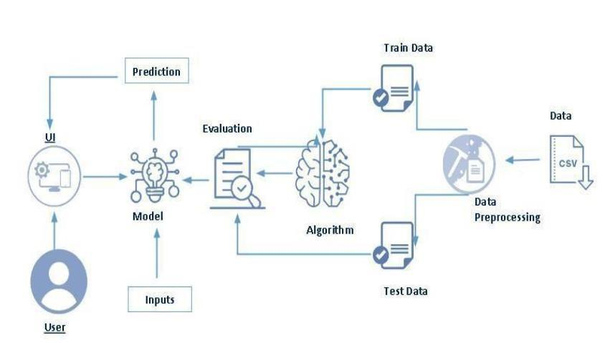

**3.2. SOFTWARE DESIGNING**

| **REQUIREMENTS** | **SPECIFICATIONS** |
| --- | --- |
| Anaconda Navigator | You must have anaconda installed in your device prior to begin. |
| * GOOGLECOLLA, JUPYTER Notebook, Flask * Frame work   . | * One should have GOOGLE COLLAB, and JUPYTER notebook. * One should install flask framework through Anaconda prompt for running their web application. * We need to build the mode; using JUPYTER notebook with all the imported packages. |
| Web browser | For all Web browsers, the following must be enabled:   * Cookies * Java script |

**Hardware requirements**:

| **REQUIREMENTS** | **SPECIFICATIONS** |
| --- | --- |
| Operating system | * Microsoft windows * Unix * Linux |
| Processing | Minimum: 4 CPU cores for one user. For each deployment, a sizing exercise is highly recommended. |
| RAM | Minimum 8 GB. |
| Operating system specifications | File descriptor limit set to 8192 on UNIX and Linux |
| Disk space | A minimum of 7 GB of free space is required to install the software. |

**4.EXPERIMENTAL INVESTIGATION**

An experimental investigation of SDSS (Sloan Digital Sky Survey) galaxy classification using machine learning (ML) typically involves several key steps:

1. Data Collection and Preprocessing:

Dataset: Use the SDSS database to collect images and/or spectra of galaxies. SDSS provides extensive photometric and spectroscopic data.

Preprocessing: Clean the data by handling missing values, normalizing the data, and possibly augmenting images if using image data.

2. Feature Extraction:

Extract relevant features from the data. For images, this might involve using techniques like PCA (Principal Component Analysis) or using pre-trained convolutional neural networks (CNNs) to extract features. For spectra, it could involve extracting specific lines or features in the spectra.

3. Labelling

Use existing classifications from SDSS or other astronomical catalogs to label the data. This often involves labels like galaxy types (e.g., elliptical, spiral) or morphological features.

4. Model Selection:

Choose appropriate ML models for classification. Common choices include:

Supervised Learning Models: Decision Trees, Random Forests, Support Vector Machines (SVM), k-Nearest Neighbors (k-NN), and neural networks.

Deep Learning Models*: Convolutional Neural Networks (CNNs) are particularly effective for image classification tasks.

For the dataset we selected, it consists of more than the columns we want to predict it. So, we have chosen the feature drop it contains the columns that we are going to predict the AQI value.

* Feature drop means it drops the columns that we don’t want in our dataset.
* Feature drop = ['PM10','NH3','Benzene','Toluene','Xylene','index']

**5.FLOWCHAT**



























## 6.RESULT

**HOME PAGE**

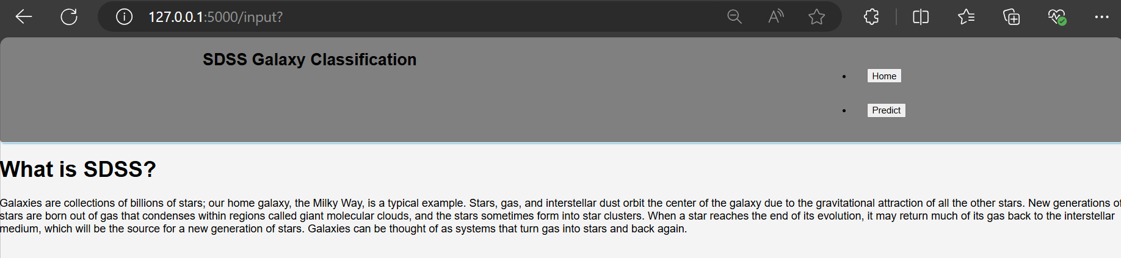

**PREDICTIONS**

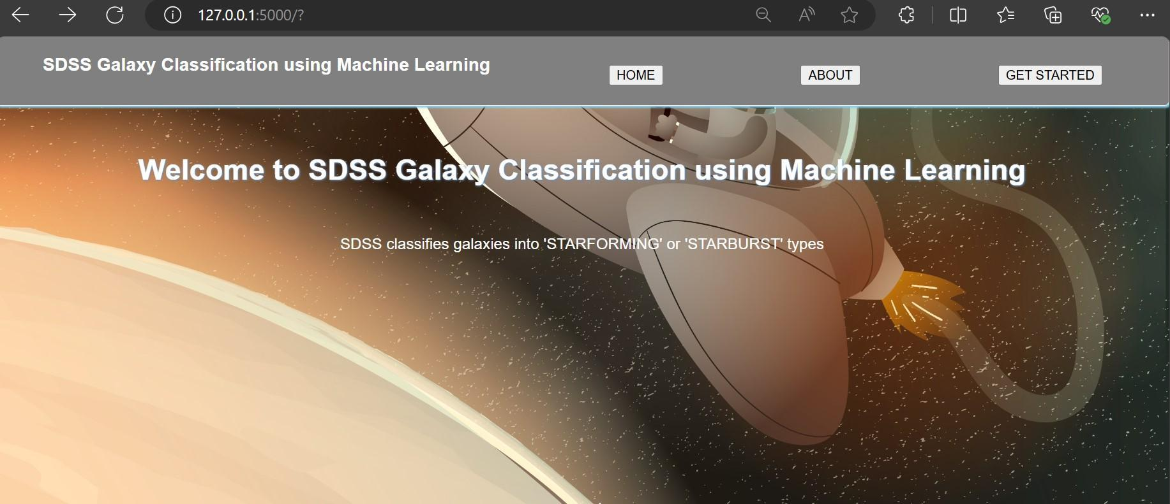

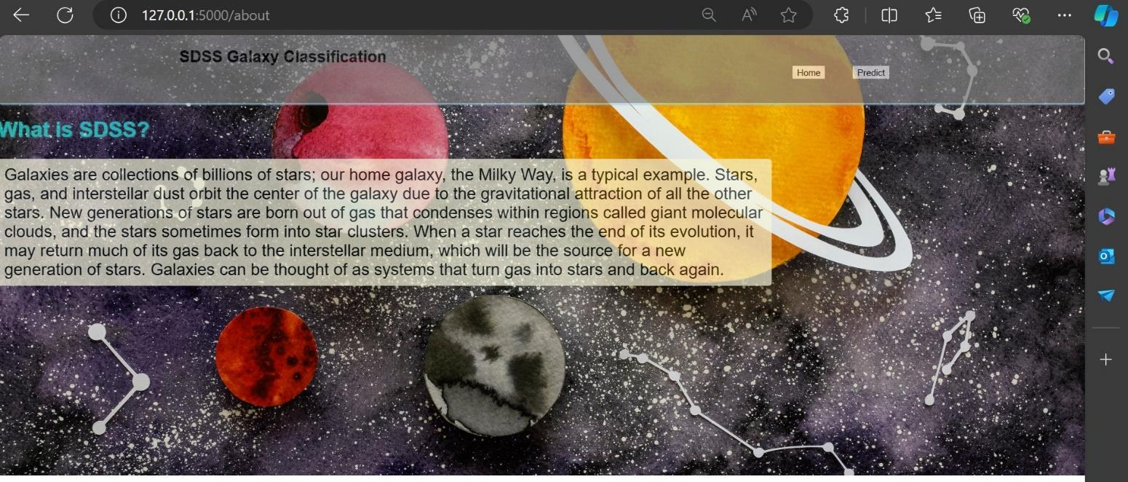

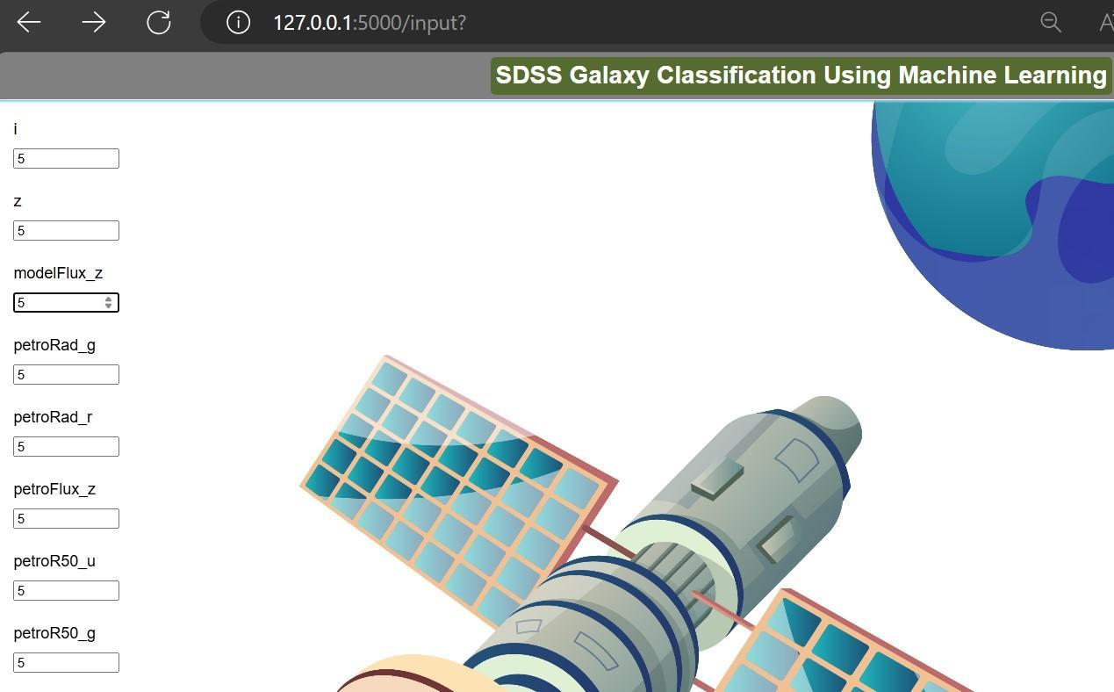

## 7.ADVANTAGES AND DISADVANTAGES

**ADVANTAGES:**

1. **Speed and Efficiency**:
   * **Automated Processing**: Machine learning algorithms can process vast amounts of data much faster than human classification, leading to quicker analysis and discoveries.
   * **Scalability**: The ability to handle large datasets, such as those from SDSS, makes machine learning suitable for extensive astronomical surveys.
2. **Accuracy and Consistency**:
   * **Reduced Human Error**: Machine learning models can maintain consistent accuracy without the variability introduced by human classifiers.
   * **Pattern Recognition**: Algorithms can identify subtle patterns and features in the data that may be overlooked by humans.
3. **Predictive Capabilities**:
   * **Generalization**: Once trained, models can generalize from known data to classify new, unseen data.
   * **Anomaly Detection**: Machine learning can be used to identify unusual or rare objects, leading to potential new discoveries.
4. **Resource Efficiency**:
   * **Cost-Effective**: Automating the classification process reduces the need for extensive human labor, potentially lowering costs.
   * **Continuous Improvement**: Machine learning models can be continuously improved with new data, enhancing their accuracy over time.
5. **DISADVANTAGES:**
6. **Data Quality and Bias**:
   * **Training Data Dependence**: The quality and accuracy of the model depend heavily on the quality and representativeness of the training data.
   * **Bias**: Models can inherit and amplify biases present in the training data, leading to skewed or inaccurate classifications.
7. **Complexity and Interpretability**:
   * **Black Box Nature**: Many machine learning models, especially deep learning, can be difficult to interpret, making it challenging to understand the reasoning behind classifications.
   * **Model Complexity**: Developing and tuning machine learning models can be complex and require significant expertise.
8. **Resource Intensive**:
   * **Computational Cost**: Training machine learning models, particularly deep learning models, can be computationally expensive and require substantial hardware resources.
   * **Data Requirements**: Large amounts of labeled data are often necessary to train effective models, which can be a limitation.
9. **Generalization Issues**:
   * **Overfitting**: Models can sometimes overfit the training data, performing well on known data but poorly on new, unseen data.
   * **Domain Specificity**: Models trained on specific datasets may not generalize well to different datasets or classification tasks without retraining

**8.APPLICATIONS**

1. **Public Health Protection**: Empowering individuals to make informed decisions regarding outdoor activities, reducing exposure to poor air quality, and minimizing health risks.
2. **Environmental Monitoring**: Assessing the impact of air pollution on the environment, ecosystems, and natural habitats, aiding in conservation efforts.
3. **Government Policy**: Assisting governments and regulatory bodies in setting air quality standards, formulating pollution control policies, and conducting effective urban planning
4. **Public Awareness**: Raising public awareness about the importance of air quality and its impact on health, influencing behavior and lifestyle choices.

## 

## 9.CONCLUSION

## In this study, we propose a convolutional neural network to classify galaxies in 10 classes. This is one of the initial, work wherein the galaxies are classified in 10 classes by considering such minute details. This detailed classification happens to be of need after considering the theoretical knowledge we have. This was initially done by professional astronomers but due to large amount of data we have, it was impossible for them to continue. Further, different citizen scientists were trained to do this task, but in modern era the data we have is huge in number compared to that of available volunteers. Hence, this algorithm happens to solve this problem. Also, the time taken by algorithm to classify large volume of dataset is less than 10 minutes which is another advantage of using the automated algorithms over manual classification. The proposed algorithm gives accuracy of 84.5 % which is good after considering such minute details in, classification.

## 10.FUTURE SCOPE

## Future Scope of SDSS Galaxy Classification

The future of SDSS galaxy classification holds significant potential for advancing our understanding of the universe. Here are some key areas where this field is expected to grow and evolve:

1. **Improved Classification Algorithms**
   * **Machine Learning and AI:** Continued development and integration of advanced machine learning techniques, such as deep learning and neural networks, will enhance the accuracy and efficiency of galaxy classification.
   * **Automated Classification:** The use of automated systems will reduce human bias and error, allowing for the consistent classification of large datasets.
2. **Integration with Multi-Wavelength Data**
   * **Cross-Survey Analysis:** Combining SDSS data with information from other astronomical surveys (e.g., X-ray, radio, infrared) will provide a more comprehensive understanding of galaxy properties and evolution.
   * **Enhanced Feature Extraction:** Multi-wavelength data can help in identifying and characterizing different features of galaxies that are not visible in optical wavelengths alone.
3. **Real-Time Data Processing**
   * **Streamlined Pipelines:** Development of real-time data processing pipelines will enable the immediate classification and analysis of incoming data from new SDSS observations.
   * **Big Data Technologies:** Utilizing big data technologies will help manage and process the enormous volumes of data generated by SDSS and other astronomical surveys.
4. **Expanded Data Sets**
   * **Next-Generation Surveys:** Future surveys, such as the Large Synoptic Survey Telescope (LSST), will provide even larger datasets, requiring more sophisticated classification techniques.
   * **Increased Data Depth:** Higher sensitivity and resolution in future observations will allow for the classification of fainter and more distant galaxies.

**11.BIBILOGRAPHY**

SDSS galaxy classification project involves listing the key sources you've used or plan to use. Here are some essential references to include:

### Books

* **Astrophysics for Physicists** by Arnab Rai Choudhuri (2010).
* **Galaxy Formation and Evolution** by Houjun Mo, Frank van den Bosch, and Simon White (2010).

### Research Papers

1. **York, D. G., et al. (2000).** The Sloan Digital Sky Survey: Technical Summary. *The Astronomical Journal, 120*(3), 1579-1587. doi:10.1086/301513.
2. **Abazajian, K. N., et al. (2009).** The Seventh Data Release of the Sloan Digital Sky Survey. *The Astrophysical Journal Supplement Series, 182*(2), 543-558. doi:10.1088/0067-0049/182/2/543.
3. **Blanton, M. R., & Roweis, S. (2007).** K-Corrections and Filter Transformations in the Ultraviolet, Optical, and Near-Infrared. *The Astronomical Journal, 133*(2), 734-754. doi:10.1086/510127.
4. **Stoughton, C., et al. (2002).** Sloan Digital Sky Survey: Early Data Release. *The Astronomical Journal, 123*(1), 485-548. doi:10.1086/324741.
5. **Eisenstein, D. J., et al. (2001).** Spectroscopic Target Selection for the Sloan Digital Sky Survey: The Luminous Red Galaxy Sample. *The Astronomical Journal, 122*(4), 2267-2280. doi:10.1086/323717.

### Websites

* [Sloan Digital Sky Survey (SDSS) official website](https://www.sdss.org/)
* [Astrophysics Data System (ADS) by NASA](https://ui.adsabs.harvard.edu/)
* [arXiv.org e-Print archive](https://arxiv.org/)

1. Anderson H. R., R.W. Atkinson, J. L. Peacock, M. J. Sweeting and L. Marston. Ambient Particulate matter and health effect; Publication bias in studies of short-term association. Epidemiol 16; 2005:

**12.APPENDIX**

**Model building :**

1)Dataset

2)Google colab and Anaconda Application Building

1. HTML file (Index file, second file, final file)

1. CSS file
2. Models in pickle format

**SOURCE CODE:**

**INDEX.HTML**

!DOCTYPE html>

<html lang="en">

<head>

    <meta charset="UTF-8">

    <meta name="viewport" content="width=device-width, initial-scale=1.0">

    <title>About</title>

    <link rel="stylesheet" type="text/css" href="{{url_for ('static', filename='style.css')}} “>

</head>

<body>

    <div class="main">

        <div class="nav">

            <nav>

                <h2>SDSS Galaxy Classification</h2>

                <ul>

                    <li>

                        <form action="{{url_for('index')}} “>

                            <button type="submit">Home</button>

                        </form>

                    </li>

                    <li>

                        <form action="{{url_for('input')}} “>

                            <button type="submit">Predict</button>

                        </form>

                    </li>

                </ul>

            </nav>

        </div>

        <div>

            <h1>What is SDSS?</h1>

            <p>Galaxies are collections of billions of stars; our home galaxy, the Milky Way, is a typical example. Stars, gas, and interstellar dust orbit the centre of the galaxy due to the gravitational attraction of all the other stars. New generations of stars are born out of gas that condenses within regions called giant molecular clouds, and the stars sometimes form into star clusters. When a star reaches the end of its evolution, it may return much of its gas back to the interstellar medium, which will be the source for a new generation of stars. Galaxies can be thought of as systems that turn gas into stars and back again.</p>

        </div>

    </div>

</body>

</html>

**SECOND.HTML**

<!DOCTYPE html>

<html lang="en">

<head>

    <meta charset="UTF-8">

    <meta name="viewport" content="width=device-width, initial-scale=1.0">

    <title>About</title>

    <link rel="stylesheet" type="text/css" href="{{url_for ('static', filename='style.css')}} “>

</head>

<body>

    <div class="main">

        <div class="nav">

            <nav>

                <h2>SDSS Galaxy Classification</h2>

                <ul>

                    <li>

                        <form action="{{url_for('index')}} “>

                            <button type="submit">Home</button>

                        </form>

                    </li>

                    <li>

                        <form action="{{url_for('input')}} “>

                            <button type="submit">Predict</button>

                        </form>

                    </li>

                </ul>

            </nav>

        </div>

        <div>

            <h1>What is SDSS?</h1>

            <p>Galaxies are collections of billions of stars; our home galaxy, the Milky Way, is a typical example. Stars, gas, and interstellar dust orbit the center of the galaxy due to the gravitational attraction of all the other stars. New generations of stars are born out of gas that condenses within regions called giant molecular clouds, and the stars sometimes form into star clusters. When a star reaches the end of its evolution, it may return much of its gas back to the interstellar medium, which will be the source for a new generation of stars. Galaxies can be thought of as systems that turn gas into stars and back again. </p>

        </div>

    </div>

</body>

</html>

**FINAL.HTML**

<!DOCTYPE html>

<html lang="en">

<head>

    <meta charset="UTF-8">

    <meta name="viewport" content="width=device-width, initial-scale=1.0">

    <title>Prediction Result</title>

    <link rel="stylesheet" type="text/css" href="{{url_for ('static', filename='style.css')}} “>

    <style>

        body {

            background: url('static\\bg3.jpg');

            background-position: centre;

            background-size: cover;

            background-repeat: no-repeat;

        }

        h1{

            color: rgb(26, 161, 134);

            filter: drop-shadow(1px 1px 1px black);

        }

        h3{

            font-size: 30px;

            color: rgb(219, 11, 11);

            filter: drop-shadow (1px 1px 1px rgb (9, 1, 1));

        }

    </style>

</head>

<body >

    <div class="container"> <centre>

        <h1>Prediction Result</h1>

        <h3 class="output">{{ prediction }}</h3> </centre>

    </div>

</body>

</html>

**MAIN.PY**

from flask import Flask, request, render_template

import pickle

import pandas as pd

# Load the trained model

with open ('RF.pkl', 'rb') as file:

    model = pickle. load(file)

app = Flask(__name__)

@app. Route ("/")

def index ():

    return render_template("index.html")

@app. route ("/about", methods=["POST", "GET"])

def about ():

    return render_template("about.html")

@app.route("/input")

def input():

    return render_template("second.html")

@app. route ('/submit', methods=["POST"]) # Specify POST method

def submit ():

    # Reading input values from the form

    input_feature = [float(x) for x in request. form. Values ()]

    names = ['i', 'z', 'modelFlux_z', 'petroRad_g', 'petroRad_r', 'petroFlux_z', 'petroR50_u', 'petroR50_g', 'petroR50_i', 'petroR50_r']

    print ("Number of columns in names:", len(names))

    print ("Number of columns in input_feature:", len(input_feature))

    print ("Column names:", names)

    data = pd.DataFrame([input_feature], columns=names)

    # Make prediction

    prediction = model.predict(data)

    # Render the output template with the prediction result

    if prediction [0] == 0:

        print(prediction)

        return render_template ('final.html', prediction='starforming')

    else:

        return render_template ('final.html', prediction='starbursting')

if __name__ == "__main__":

    app.run(debug=True)

## CODE SNIPPETS

### MODEL BUILDING

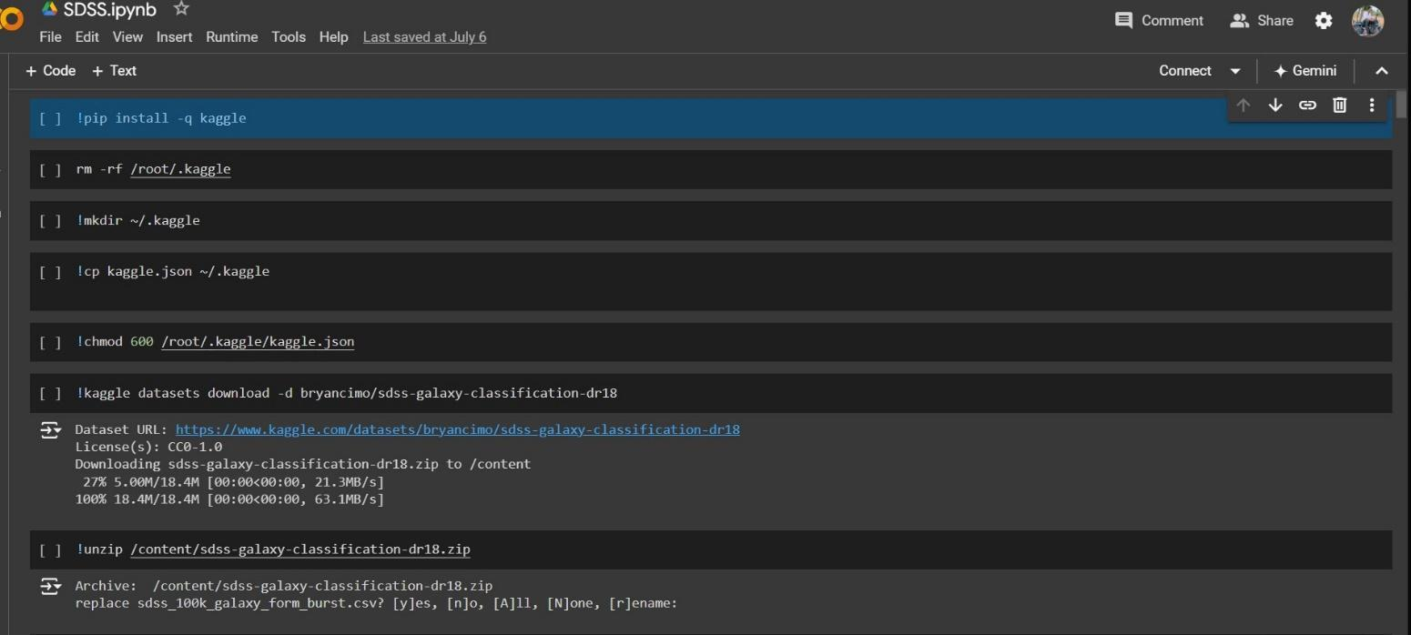

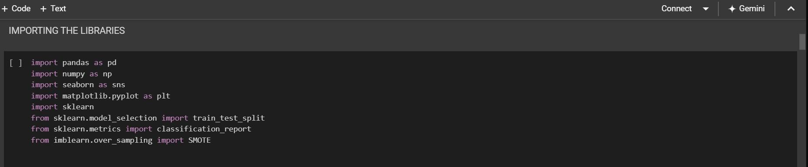

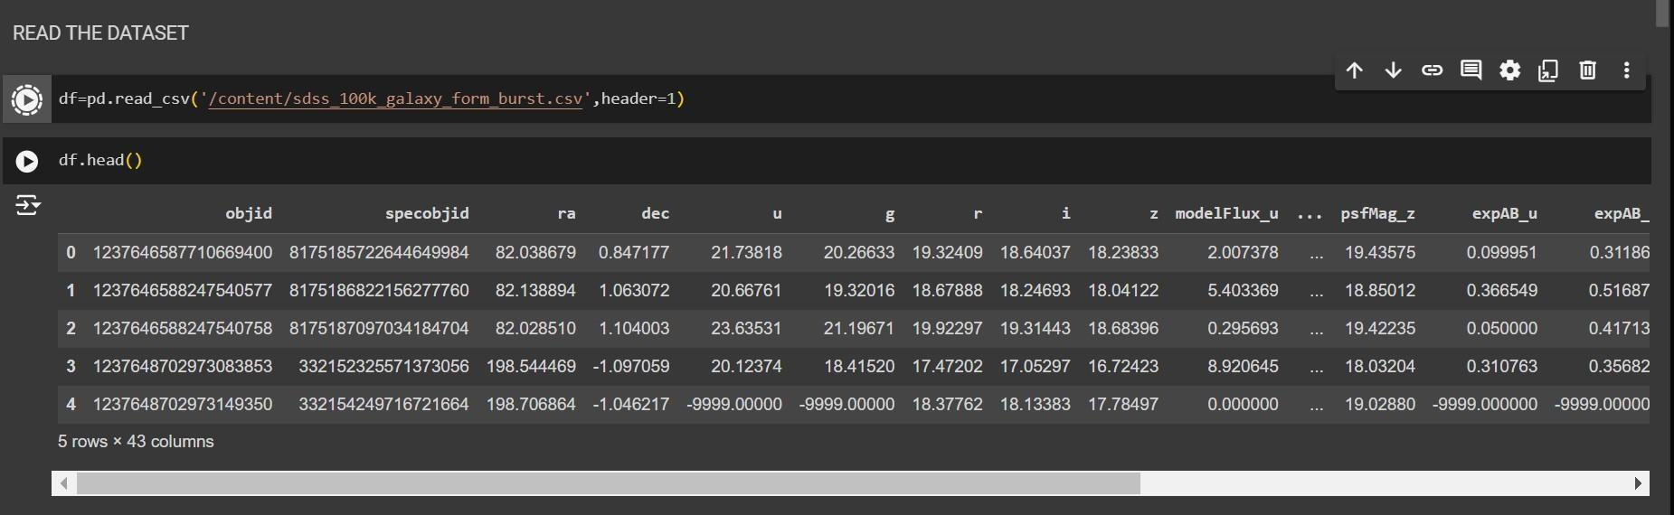

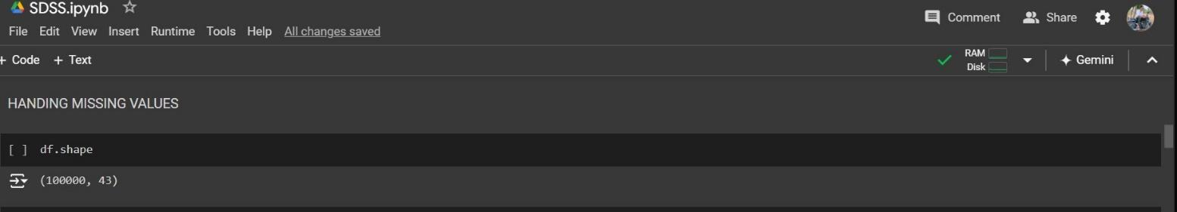

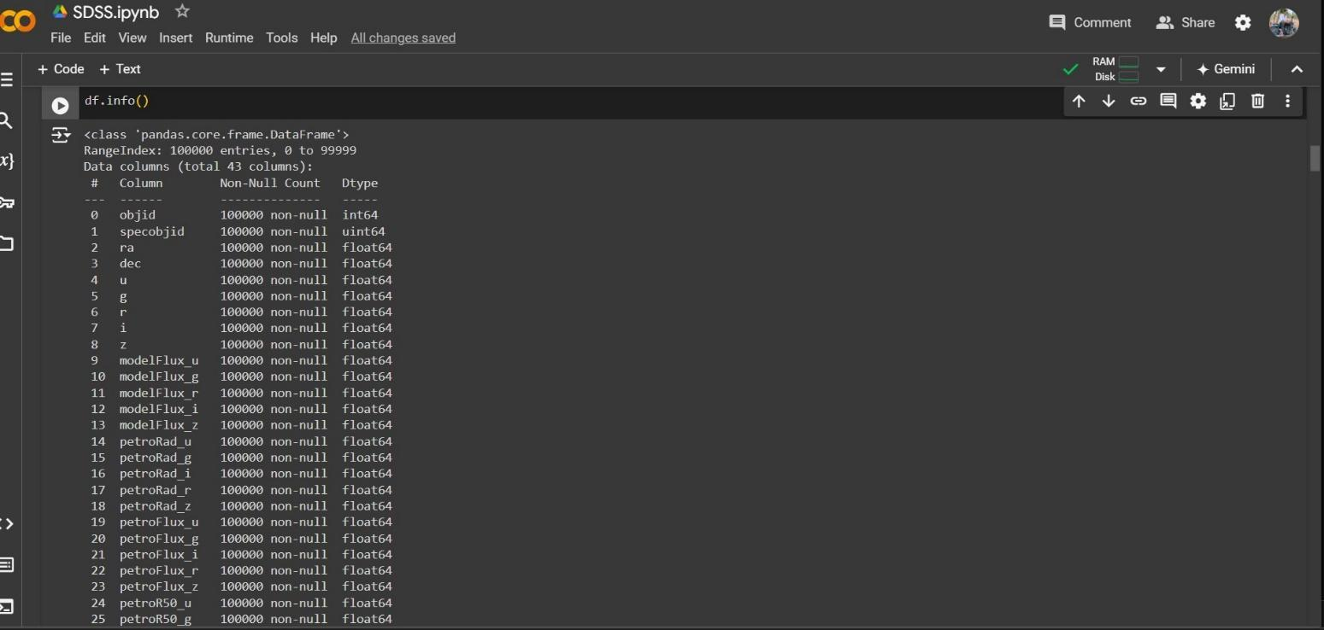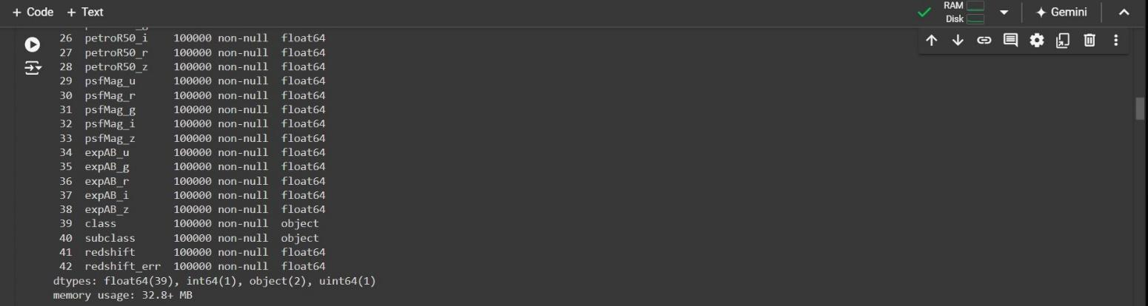

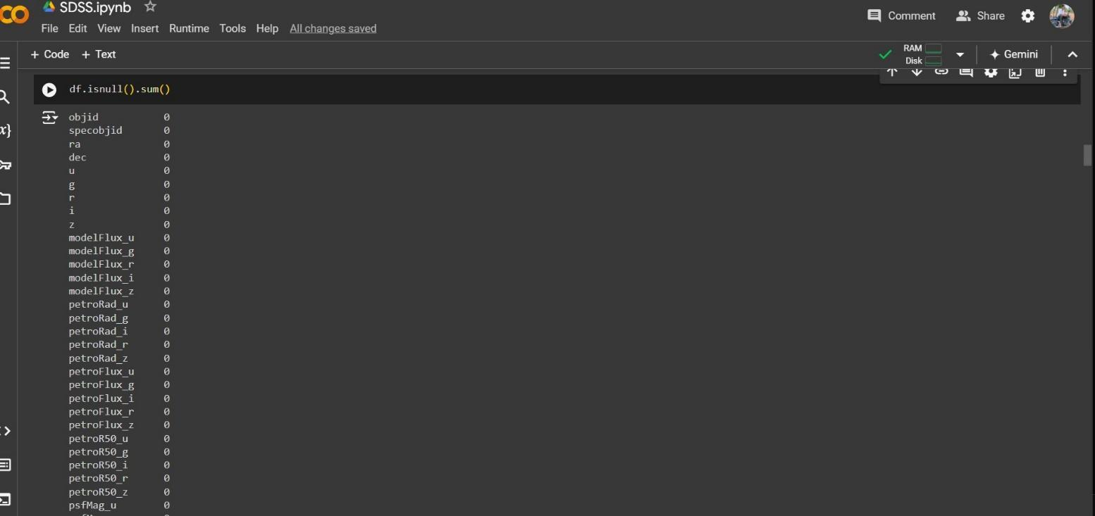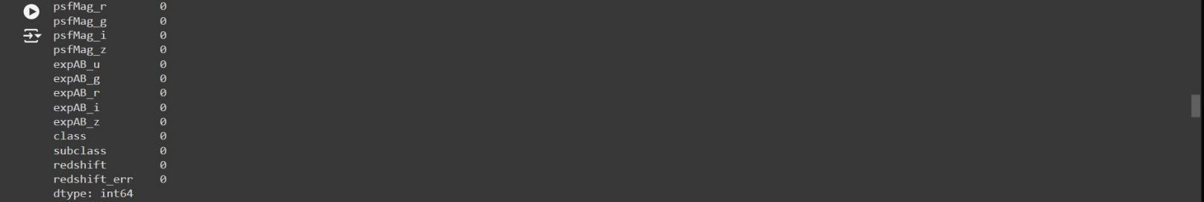

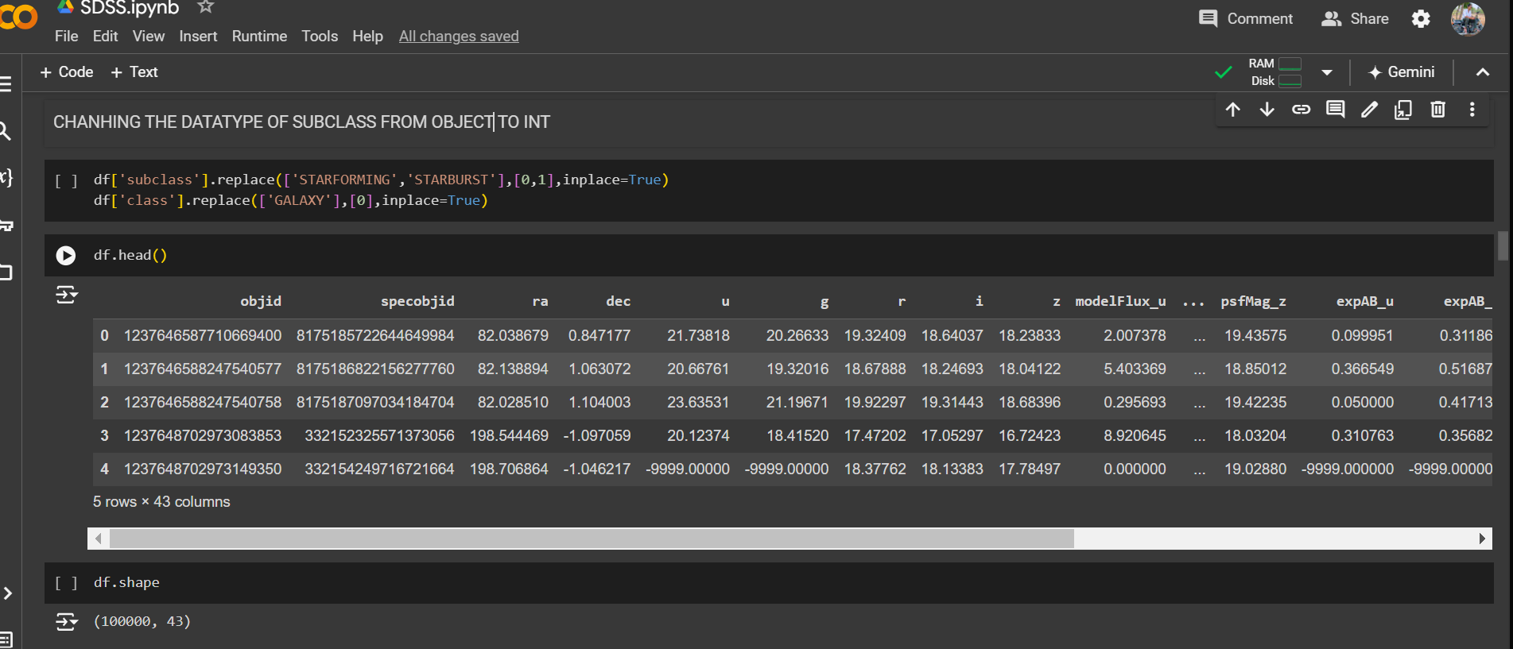

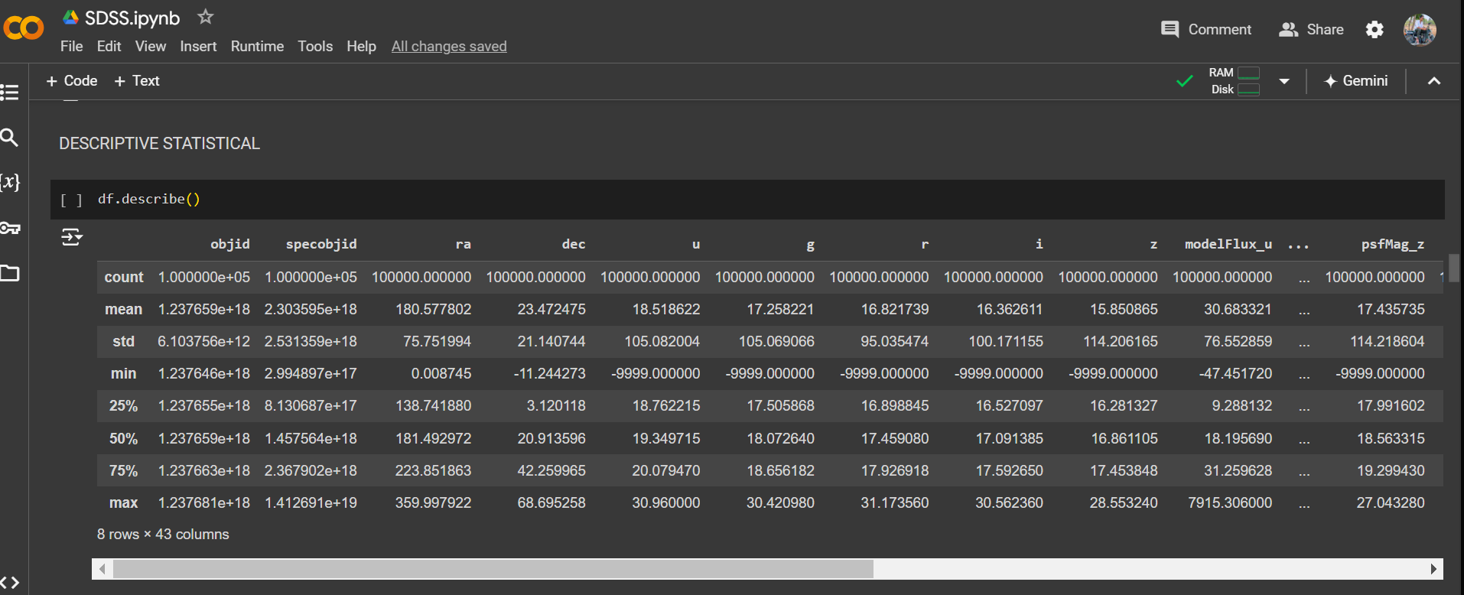

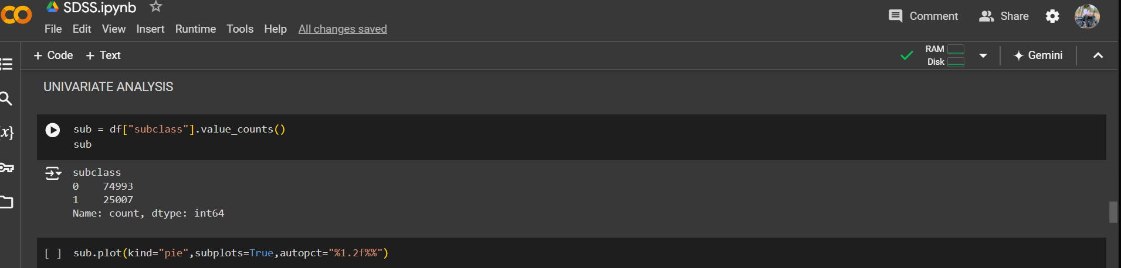

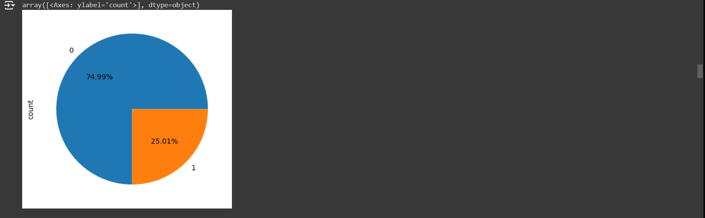

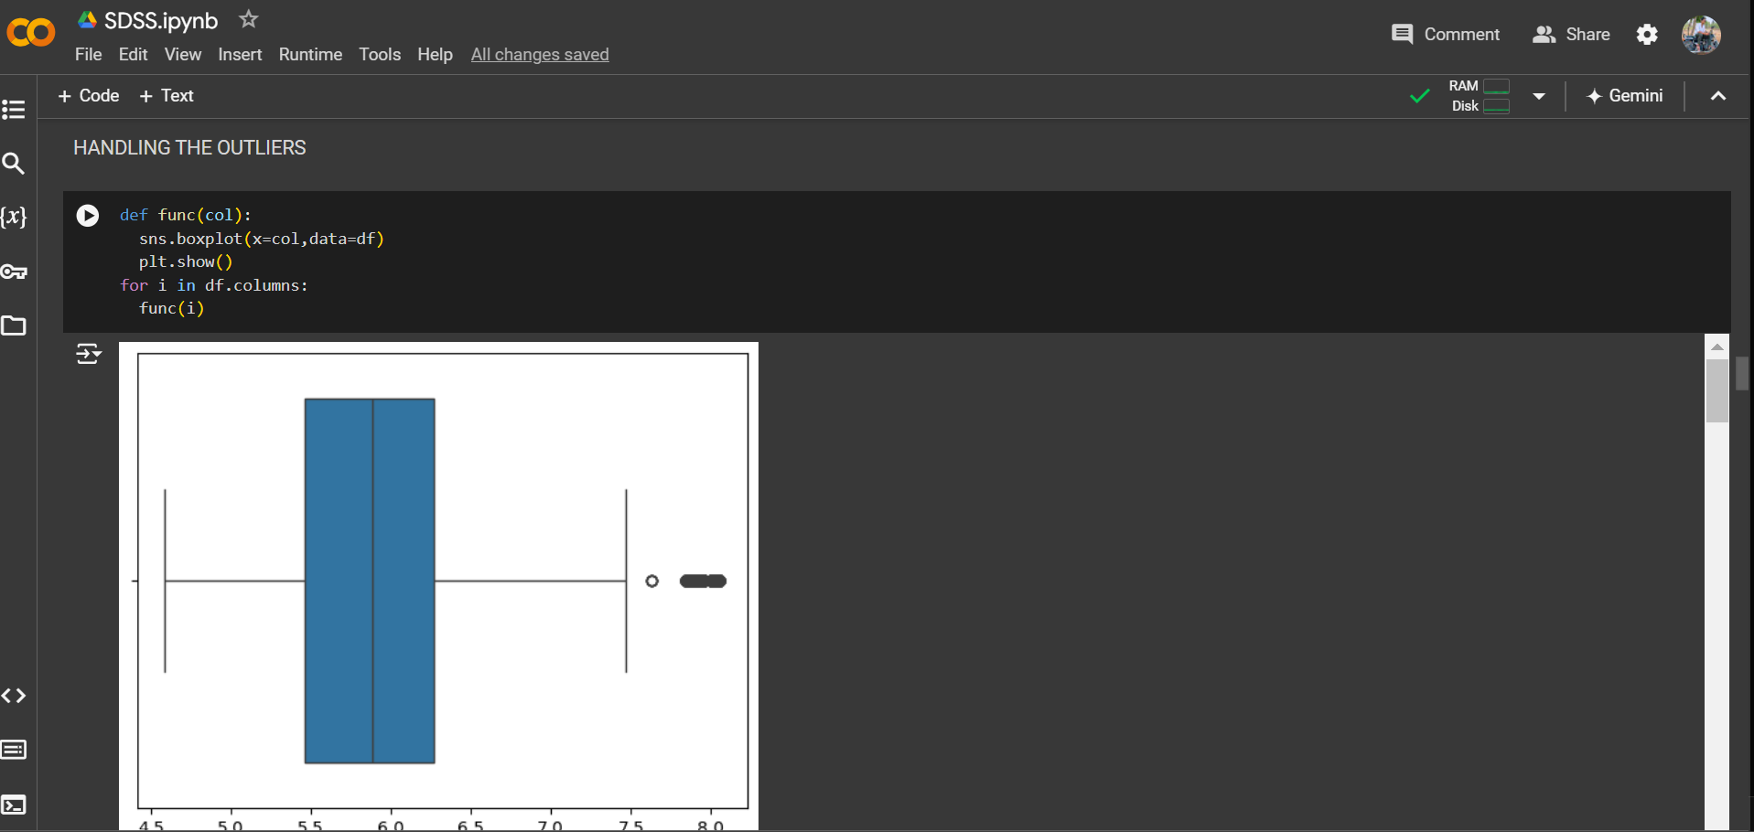

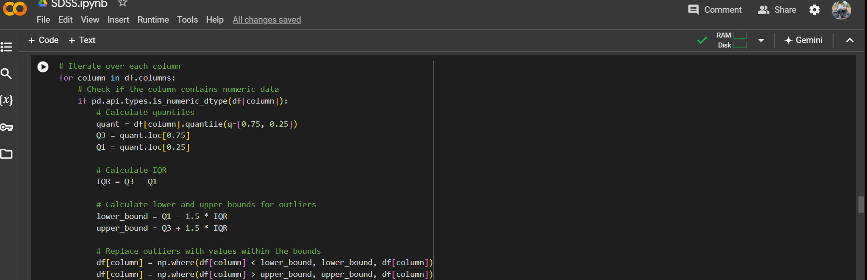

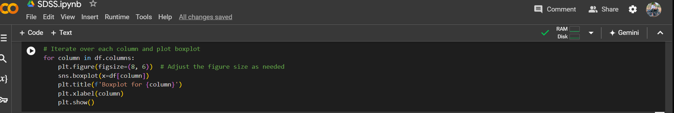

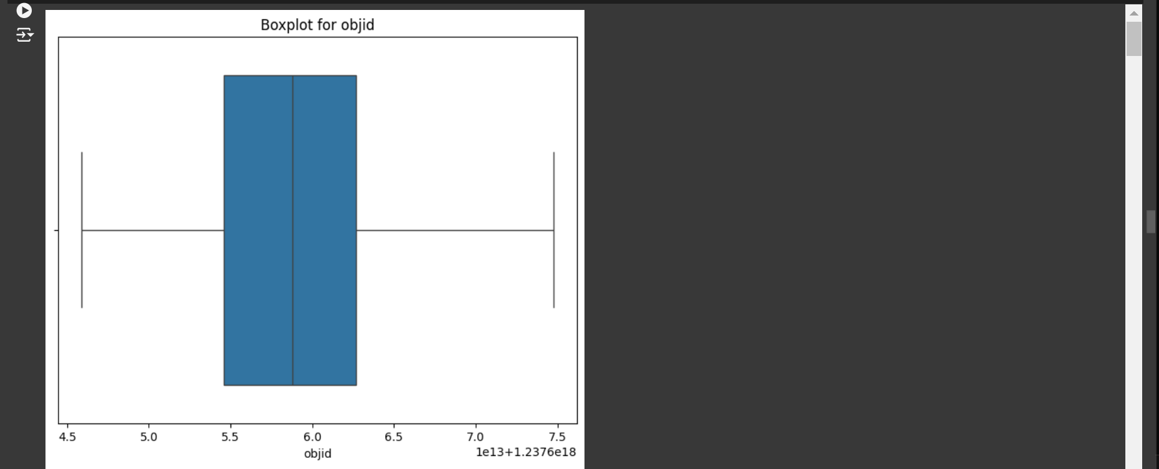

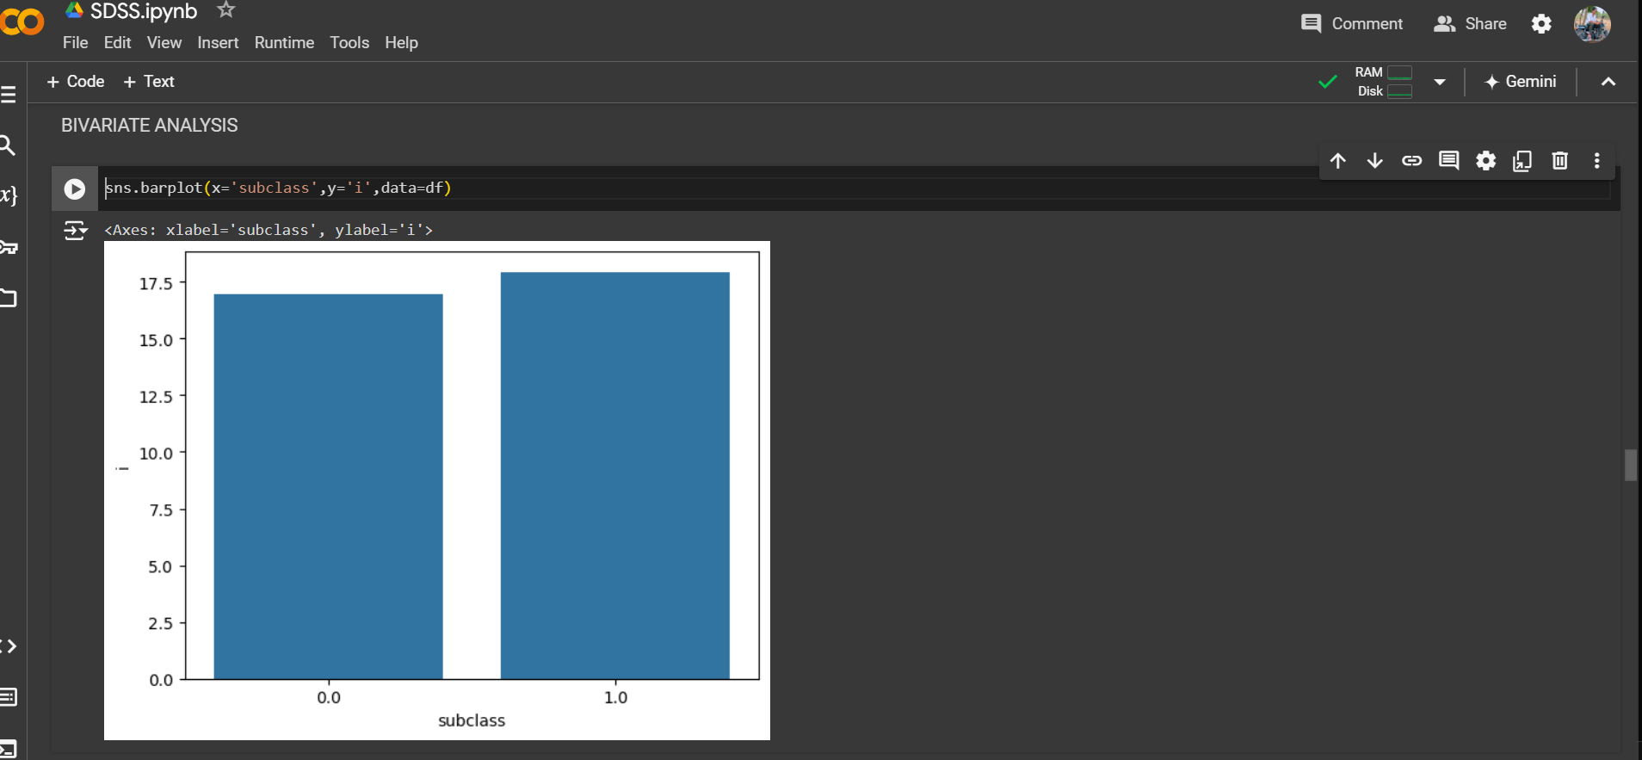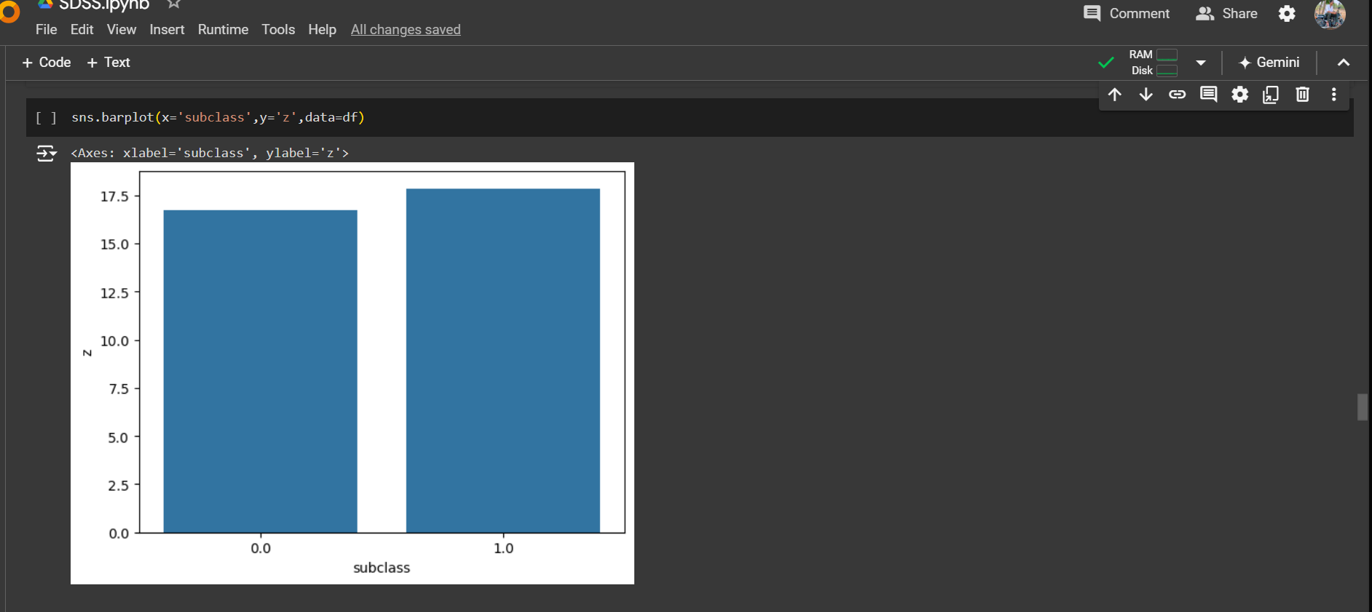

### HEAT MAP





